TAP AG Project Title / Facility Name:
Trans Adriatic Pipeline Project

Waste Management Monitoring Report
During construction
(Period September – November 2020)
Area interested by phase 3
0 | 14/12/2020 | Issued for Information |  | IFI | P. Fantini | A. D’urso |  | M. Landeschi
Rev. | Data revisione (gg-mm-aaaa) | Motivo dell’emissione |  |  | Preparato da | Verificato da |  | Approvato  da
 |  |  | Contrattore nome:
 |  |  | Contrattore Progetto No.:
 |  |  | Contrattore Doc. No.:
 |  |  | Tag No's.: N/A
TAP AG Contratto No.: C28198 |  |  | Progetto No.:
PO No.: |  |  |  |  |  |  | Pagina: 1 of 18
TAP AG Documento No.:

CAL00-C28198-601-Y-TRY-0053

INDEX
1. INTRODUCTION 3
2. SURVEY’S SCOPE 3
3. MONITORING ACTIVITIES 5
4. RISULTS 6
5. CONCLUSIONS 7

ANNEX
Annex 1 – FIR Example and Laboratory Tests

INTRODUCTION
This document describes the waste management survey “during construction” phase at Onshore Pipeline Installation (OPLI). This monitoring activity is in response to prescription A.31 (D.M. 223 del 11/09/2014). The prescription has been receipted by the Environmental Monitoring Project (EMP) for the working area OPLI.
The OPLI works are began January 2019: During period of this report, minor works and site maintenance activities were carried out.

SURVEY’S SCOPE
The waste management monitoring requires a periodic check of the excavation materials deriving from the construction activities in the OPLI construction site.
The Contractor scope is to promote the minimization of waste, based on the ALARP principle ("As low as reasonably practicable"), with the aim of reducing the volume and quantity of waste generated, both dangerous waste and non-hazardous waste. This approach is based on an organized, exhaustive and continuous commitment to systematically reduce waste production.
In Figure 1 and shows the layout of the OPLI construction site.
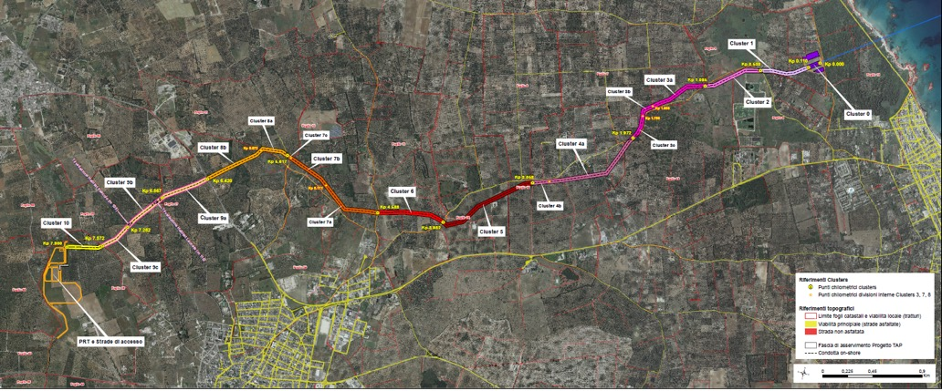
Figure 1: OPLI construction site layout.
Regarding the preparation and management of the temporary storage areas relating to the areas interested by the pipeline laying, please refer to document IPL00-C5522-200-Y-TRX-0001 “Soil protection and primary water management measures and second rain from waterproofed surfaces - assembly and installation phase of the pipeline section on the ground - Prescription a.36 "sent to ISPRA and ARPA Puglia with protocol note TAP LT-TAPIT-ITSK-01573 of 18/01/2019.
As reported in the previously document, the waste stock are been moved from the OPLI site to the temporary waste storage area 9+10 inside the MT construction site every day (Figure 2). (cfr. report CAL00-C28198-601-Y-TRY-0047).
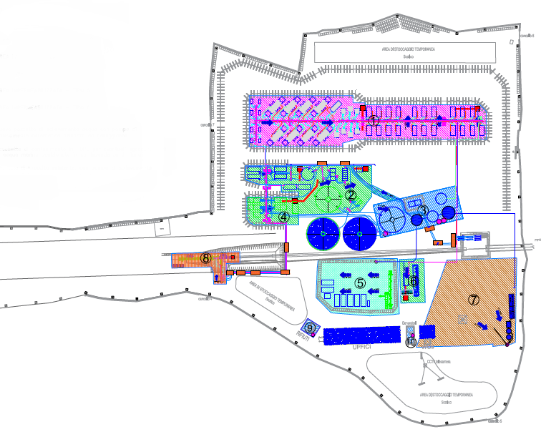
Figure 2: The layout of the MT construction site with the temporary waste storage area

MONITORING ACTIVITIES
The waste management procedures and measures together with the monitoring and inspection procedures include the following:
- Monitoring of waste from their production to their disposal. The waste is tracked, characterized and recorded in accordance with Legislative Decree 152/06 and subsequent amendments. All the different types of waste generated are classified and labeled with a code from the European Waste Catalog (CER) on the basis of the production processes that generated them and waste characterization analyzes.
- Monitoring of the transport of special waste from the place of production to the chosen waste disposal plant upon completion of the Waste Transport Form (FIR) as per current legislation; a copy of the FIR is kept at the OPLI site.
- Monitoring of the loaded and unloaded waste reported in the appropriate Loading and Unloading Register (in Italian called “Registro di Carico e Scarico”, abbreviated RCS) by the waste producer. The loading and unloading operations are transcribed on RCS within the legal term of 10 working days; a copy of the RCS is kept at the OPLI construction site offices.

RISULTS
The table below shows the waste managed respectively in September, October and November 2020.
Table 1: Waste managed in September 2020
MONTH | CER | Description EER | Waste Destination | Quantity (kg)
September 2020 | 161002 | Aqueous liquid wastes other than those mentioned in 161001 | D8 | 260.200
 | 170504 | Soils and stones, other than those mentioned in 170503 | R13 | 2.220.120
 | 200304 | Septic tank sludge | D8 | 4.310

Table 2: Waste managed in October 2020
MONTH | CER | Description EER | Waste Destination | Quantity (kg)
October  2020 | 150106 | Mixed packaging | R13 | 960
 | 200301 | Mixed urban waste | R13 | 220
 | 200304 | Septic tank sludge | D8 | 4.960

Table 2: Waste managed in November 2020
MONTH | CER | Description EER | Waste Destination | Quantity (kg)
November  2020 | - | - | - | -

The monitoring of the transport of waste from the place of production to the chosen plant is carried out by checking the Waste Identification Form (FIR).
Annex 1 shows, as an example, the fourth copy of a FIR relating to the monitored period. The information regarding the waste transport is indicated under the heading "Transporter" and "Mode and means of transport". TAP AG, if requested, is available to supply all the FIRs and related Test Reports currently stored at the site.
During the reference months, all types of waste produced were first temporarily deposited in the areas designated for this use, and then transferred to the destination plant.

CONCLUSIONS
This document refers to waste management during the period September – October – November 2020.
During this period of this report, minor works and site maintenance activities were carried out.
During the activities relating to the reference quarter, 5 types of waste were produced.
In Annex 1 shows, a fourth copy of a FIR of the period in question and the related Test Report which certifies the CER code of the waste produced.
Annex 1 – FIR Example and Laboratory Tests

