TAP AG Project Title / Facility Name:
Trans Adriatic Pipeline Project

Waste Management Monitoring Report
During construction
(Period September – November 2020)
Area interested by phase 2
 |  |  |  |  |  | 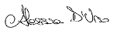
0 | 15/12/2020 | Issued for Information |  | IFI | P. Fantini | A. D’urso |  | M. Landeschi
Rev. | Data revisione (gg-mm-aaaa) | Motivo dell’emissione |  |  | Preparato da | Verificato da |  | Approvato  da
 |  |  | Contrattore nome:
 |  |  | Contrattore Progetto No.:
 |  |  | Contrattore Doc. No.:
 |  |  | Tag No's.: N/A
TAP AG Contratto No.: C28198 |  |  | Progetto No.:
PO No.: |  |  |  |  |  |  | Pagina: 1 of 18
TAP AG Documento No.:

CAL00-C28198-601-Y-TRY-0055

INDEX
1. INTRODUCTION 3
2. SURVEY’S SCOPE 3
3. MONITORING ACTIVITIES 5
4. RESULTS 6
5. CONCLUSIONI 8

ANNEX
Annex 1 – FIR Example and Laboratory Tests

INTRODUCTION
This document describes the waste management survey “during construction” phase at Pipeline Receiving Terminal (PRT). This monitoring activity is in response to prescription A.31 (D.M. 223 del 11/09/2014). The prescription has been receipted by the Environmental Monitoring Project (EMP) for the working area PRT.

SURVEY’S SCOPE
The waste management monitoring requires a periodic check of the excavation materials deriving from the construction activities in the PRT construction site.
The Contractor scope is to promote the minimization of waste, based on the ALARP principle ("As low as reasonably practicable"), with the aim of reducing the volume and quantity of waste generated, both dangerous waste and non-hazardous waste. This approach is based on an organized, exhaustive and continuous commitment to systematically reduce waste production.
In Figure 1 shows the layout of the PRT construction site, withe the temporary waste storage area highlighted – Area 1, following the removal of the waste area 9 + 10 in July 2020 (cfr. report CAL00-C28198-601-Y-TRY-0049).

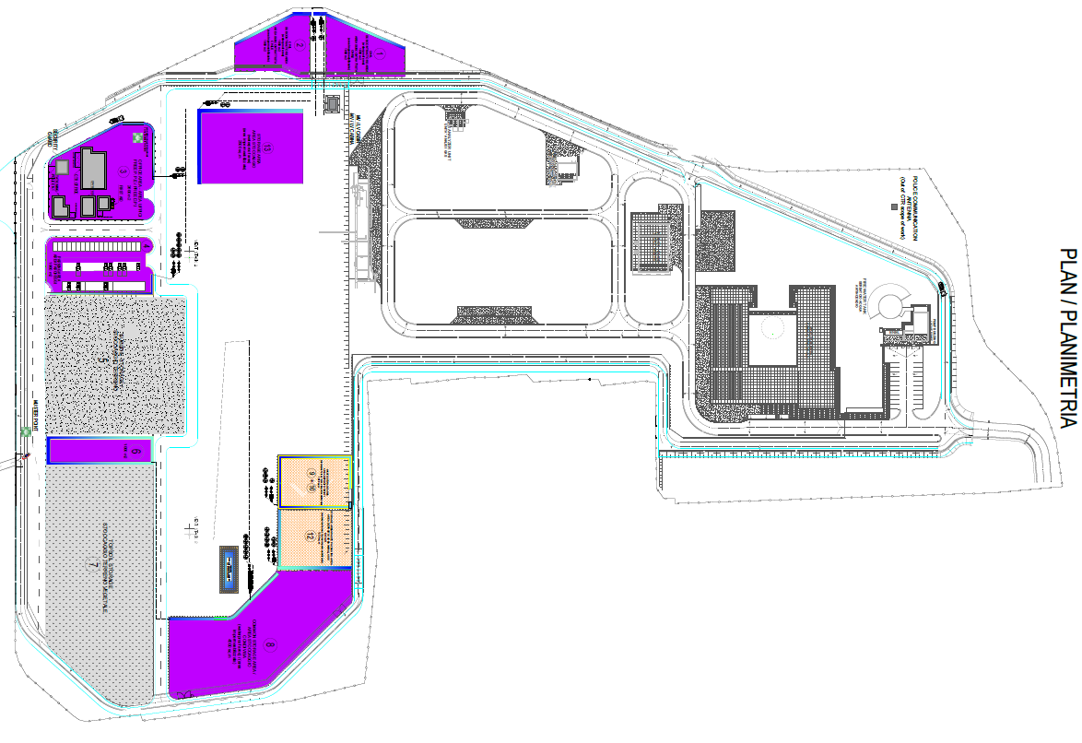
Area 1
Figure 1: PRT construction site layout showing the temporary waste storage areas 9-10.

MONITORING ACTIVITIES
The monitoring requires a periodic check of the excavation materials deriving from the activities in progress at the PRT site.
The waste management procedures and measures together with the monitoring and inspection procedures include the following:
- Monitoring of waste from their production to their disposal. The waste is tracked, characterized and recorded in accordance with Legislative Decree 152/06 and subsequent amendments. All the different types of waste generated are classified and labeled with a code from the European Waste Catalog (CER) on the basis of the production processes that generated them and waste characterization analyzes.
- Monitoring of the transport of special waste from the place of production to the chosen waste disposal plant upon completion of the Waste Transport Form (FIR) as per current legislation; a copy of the FIR is kept at the PRT site.
- Monitoring of the loaded and unloaded waste reported in the appropriate Loading and Unloading Register (in Italian called “Registro di Carico e Scarico”, abbreviated RCS) by the waste producer. The loading and unloading operations are transcribed on RCS within the legal term of 10 working days; a copy of the RCS is kept at the PRT construction site offices.

RESULTS
The tables below show the waste managed respectively in September, October. November 2020.
The definitive quantity of EER of July and August 2020 was reported in Table 1, following the implementation of IV copies (CAL00-C28198-601-Y-TRY-0049).

Table 1: Rifiuti gestiti nel trimestre giugno – agosto 2020
Month | CER | CER Description | Final Destination | Waste Destination
JULY  2020 | 170201 | Wood | R13 | 3.950
 | 170203 | Plastic | D15 | 80.840
 | 170405 | Iron and steel | R13 | 2.200
 | 200304 | Septic tank sludge | D8 | 131.650
AUGUST  2020 | 170203 | Plastic | D15 | 49.800
 | 200304 | Septic tank sludge | D8 | 141.640

Table 2: Waste managed in September 2020
Month | CER | CER Description | Final Destination | Waste Destination
SEPTEMBER  2020 | 170203 | Plastic | D15 | 60.970
 | 170402 | Aluminum | R13 | 590
 | 170603* | Other insulating materials containing or consisting of dangerous substances | D15 | 2.630
 | 200304 | Septic tank sludge | D8 | 124.750

Table 3: Waste managed in October 2020
Month | CER | CER Description | Final Destination | Waste Destination
OCTOBERE  2020 | 150105 | Packaging in composite materials | R13 | 2.740
 | 170203 | Plastic | D15 | 75.490
 | 170904 | Mixed construction and demolition waste, other than those mentioned in 170901, 170902 and 170903 | R13 | 401.880
 | 200304 | Septic tank sludge | D8 | 101.800

Table 4: Waste managed in November2020
Month | CER | CER Description | Final Destination | Waste Destination
NOVEMBER  2020 | 080318 | Waste printing toner, other than those mentioned in 080317 | R13 | 20
 | 170904 | Mixed construction and demolition waste, other than those mentioned in 170901, 170902 and 170903 | R13 | 67.520
 | 200304 | Septic tank sludge | D8 | 81.020

The monitoring of the transport of waste from the place of production to the chosen plant is carried out by checking the Waste Identification Form (FIR). Annex 1 shows, as an example, the fourth copy of a FIR relating to the monitored period. The information regarding the waste transport is indicated under the heading "Transporter" and "Mode and means of transport". TAP AG, if requested, is available to supply all the FIRs and related Test Reports currently stored at the site. During the reference months, all types of waste produced were first temporarily deposited in the areas designated for this use, and then transferred to the destination plant.

CONCLUSIONI
This document refers to waste management at the period September, October and November 2020.
During the activities relating to the reference quarter, 7 types of waste were produced.
Annex 1 shows, a fourth copy of a FIR of the period in question and the related Test Report which certifies the CER code of the waste produced.

Annex 1 – FIR Example and Laboratory Tests

