**Supplemental Material**

Perfluoroalkyl substances (PFAS) contamination in fish of European lakes

1. **Lake characteristics**

Table S1. Main characteristics of sampled lakes

|  |  |  |  |  |  |  |  |  |  |  |
| --- | --- | --- | --- | --- | --- | --- | --- | --- | --- | --- |
|  | **Geneva** | **Lake Sassolo (Upper)** | **Lake Sassolo (Lower)** | **Mergozzo** | **Maggiore** | **Varese** | **Lugano** | **Como** | **Iseo** | **Garda** |
| **Altitude (m a.s.l.)** | 372 | 2,128 | 2,074 | 195 | 193 | 238 | 271 | 198 | 186 | 65 |
| **Area (km2)** | 580 | 0.08 | 0.05 | 1.81 | 213 | 15 | 49 | 146 | 61 | 368 |
| **Maximum depth (m)** | 310 | 29 | 33 | 74 | 370 | 26 | 288 | 425 | 251 | 350 |
| **Mean depth (m)** | 154 | 13 | 11 | 45 | 178 | 11 | 134 | 154 | 123 | 133 |
| **Volume (km3)** | 89 | 0.001 | 0.0005 | 0.8 | 37 | 0.2 | 6.5 | 22 | 8 | 49 |
| **Catchment area (km2)** | 7,975 | 1 | 1.78* | 10 | 6,599£ | 112 | 566 | 4,508 | 1,842 | 2,290 |
| **Main inflow** | Rhône |  |  | Rio Rescina | Ticino, Toce | Brabbia | Vedeggio, Cassarate | Adda | Oglio | Sarca |
| **Main outflow** | Rhône | Water flows in Lake Sassolo (Lower) | Maggia  (flowing in Lake Maggiore) | Mergozzo  (flowing in Lake Maggiore) | Ticino | Bardello  (flowing in Lake Maggiore) | Tresa  (flowing in Lake Maggiore) | Adda | Oglio | Mincio |
| **Mean outflow discharge**  **(m3 s−1)** | 251 |  |  |  | 291 | 2.5 | 25 | 158 | 59 | 58 |
| **Theoretical retention time (years)** | 11.4 |  |  | 6 | 4.1 | 1.7 | 8.3 | 12.7 | 4.5/7.2 | 26.6 |
| **Total P (μg P L–1)** | 20 | <10 | <10 | <10 | 10 | 80 | 20 (northern basin)  40 (southern basin) | 25 | 70 | 18 |
| **O2 hypolimnetic**  **(mg L-1)** | <4 | 9 | 9 | <4 | 8 | <4 | <4 | 8 | <4 | 8 |
| **Catchment inhabitants** | 1,083,431 | - | - | 2,151 | 923,861 | 71,497 | 290,000 | 555,769 | 191,527 | 156,300 |

*Includes the catchment of Lake Sassolo (Upper); £ Includes the catchments of Lakes Sassolo, Mergozzo, Varese and Lugano

1. **Fish characteristics**

Table S2. Biological and ecological characteristics of the sampled species

|  |  |  |  |  |  |  |  |
| --- | --- | --- | --- | --- | --- | --- | --- |
| **Species** | **Common name** | **Family** | **Habitat** | **Diet** | **Fishbase Trophic Level (based on model)** | **Sex maturity** | **Spawning** |
| *Lota Lota* | Burbot | Lotidae | Demersal | Smaller individuals: insect larvae, crayfish, mollusks, other invertebrates. Larger individuals: fish | 3.8 ± 0.2 | Males at 2 years, females at 3 years | November-March |
| *Rutilus rutilus* | Common roach | Cyprinidae | Benthopelagic | Mainly benthic invertebrates, zooplankton, plant material and detritus | 3.0 ± 0.0 | Males at 2-3 years, females at 3-4 years |  |
| *Alosa agone* | Agone | Clupeidae | Pelagic | Mainly cladocerans and copepods, also small fish | 3.8 ± 0.4 | Males at 2-3 years, females at 3-4 years | June-August |
| *Coregonus lavaretus* | European whitefish | Salmonidae | Demersal | Planktonic crustaceans, or larger benthic crustaceans in brackish water | 3.1 ± 0.0 |  | December |
| *Salvelinus alpinus* | Arctic char | Salmonidae | Benthopelagic | Planktonic crustaceans, amphipods, mollusks, insects and fish | 4.4 ± 0.5 | 4-10 years | September -December |
| *Perca fluviatilis* | European perch | Percidae | Demersal | Predatory and opportunistic diurnal feeder, both invertebrates and fish | 4.4 ± 0.0 | Males at 1-2 years, females at 2-4 years | February-July |
| *Oncorhynchus mykiss* | Rainbow trout | Salmonidae | Benthopelagic | Variety of aquatic and terrestrial invertebrates and small fish | 4.1 ± 0.3 | Males at 2 years, females at 3 years | November-May in the Northern hemisphere |
| *Salmo trutta* | Trout | Salmonidae | Demersal | Predatory and opportunistic. Mollusks, crustaceans and small fish | 3.4 ± 0.1 | 3 - 4 years |  |

Table S3. Sampling and biometric values of the fish samples (see excel file). n.d. not determined

1. **Analysis**

**Protein content evaluation**

Protein content evaluation was conducted on fillets, carcasses and viscera of selected fish of Lake Iseo, Lake Como and Lake Garda, according to Bradford (1976). The Bradford method is a colorimetric method based on the shift of absorbance following the bond between the proteins and the dye Coomassie blue (Coomassie Brilliant Blue G-250; CBBG; Bradford reagent). Samples were singularly weighed (~ 0.2 g) and homogenized in a 100 mM phosphate buffer (100 mM KCl, 1 mM EDTA, pH 7.4) added with specific protease inhibitor (1:100 v/v) and dithiothreitol (DTT, 100 mM). The protein content was evaluated in triplicate on the supernatant (S9 fraction) obtained by the centrifugation at 16,000 × g for 20 min of the raw homogenate. In detail, 5 µL of sample was added to a mix of 1450 µL of Bradford reagent and 45 µL of 100 mM phosphate buffer (100 mM KCl, 1 mM EDTA, protease inhibitor, DTT) in order to be read at λ = 595 nm, by means of a Genova Bio spectrophotometer (Jenway). The obtained values were normalized using a standard calibration curve prepared with bovine serum albumin (BSA; 2 mg/L). The protein content was expressed as mg/mL (mg proteins / mL) and as mg/g (mg proteins / sample weight). The protein content was calculated using a standard calibration curve prepared with five dilution of bovine serum albumin (BSA; mother stock: 2 mg/L) and expressed as mg/g (mg proteins / sample weight).

**Polar lipid extraction**

The extraction polar lipids was conducted o on fillets, carcasses and viscera of selected fish of Lake Iseo, Lake Como and Lake Garda, according to a protocol developed by Palacios (2005) with slight adjustment. In detail, the sample taken by each fish was weighted (~ 0.2 g), homogenized with 10 mL of ethanol (95%) and centrifuged at 19,000 × g for 5 min. The supernatant containing polar lipids, some neutral lipids and water was transferred and stored in a separatory funnel. Moreover, the remaining pellet was washed twice with 5 mL of hexane (10 minutes each) and twice with 10 mL of ethanol (95%) in order to extract the residual lipids, and then the obtained suspension was transferred to the separatory funnel. The separatory funnel was gently mixed and left to equilibrate for 2 hours in order to allow the phase separation. The I phase (ethanol), containing the polar lipids, was removed and transferred in a glass bottle (~ 30 mL) and then combined with the supernatant of a second wash of ethanol (90%), performed in order to extract the residual polar lipids. Furthermore, the ethanol was evaporated and the polar lipids content was determined gravimetrically. The phase II (hexane; ~ 20 mL), was transferred to a glass flask, dried by rotary evaporation and the neutral lipids content was determined gravimetrically.

**PFAS chemical analysis**

*Chemicals and Standards*

All reagents were analytical reagent grade. LC–MS grade Chromasolv acetonitrile and concentrated formic acid were purchased from Sigma-Aldrich. Water (<18 MΩcm resistivity) was produced by a Millipore Direct-QUV water purification system (Millipore, Bedford, MA, USA). HybridSPE®Phospholipid Ultra cartridges (30 mg, 1 mL SPETubes) were obtained by Sigma Aldrich (St. Louis, Missouri, USA).

SPE Oasis WAX (150 mg, 6 mL) were obtained by Waters (Manchester, England) and carbon SPE (500mg, 6 mL) by Sigma Aldrich (Saint-Quentin-Fallavier, France).

Certified PFAS native compounds and isotope-labelled internal standards (ISs) were purchased from Wellington Laboratories, Inc. (Guelph, Ontario, Canada). PFAC-MXC Stock Solution containing native PFCAs and PFASs was diluted in acetonitrile to prepare calibration standard solutions. Mass-labelled MPFAC-MXA solution (Wellington Laboratories, Inc.) was diluted in acetonitrile (40 µg/L) for the preparation of the stable isotope labelled solution used as internal standard mixture (SIL-IS). Details on the analyte names, abbreviations and corresponding IS are reported in Table S4 and S4b.

*Sample extraction and PFAS analysis at Water Research Institute*

The extraction of fish fractions was carried according to Mazzoni (2016). Briefly, few grams of homogenized pooled samples were weighed (viscera: 3 g ww; muscle: 10 g ww; carcass: 5 g ww) into a 50 mL polypropylene (PP) centrifuge tube and spiked with 100 µL of SIL-IS solution (40 µg/L). Samples were extracted by sonication in an acidified water and acetonitrile (10:90 v/v) solution (1.5 mL of water and acetonitrile solution per gram of fresh sample) and subsequent purification on MgSO4/NaCl. To remove phospholipids, volume reduced extracts (1 mL) were filtered through HybridSPE®Phospholipid Ultra cartridges, previously cleaned with 3 mL of acetonitrile and 50 µL of formic acid (1 cartridge for carcass and muscle extract and 2 cartridges for viscera extracts). PFAS in the final extract were determined by liquid chromatography tandem mass spectrometry (UHPLC-MS/MS) coupled to a turbulent flow chromatography (TFC) for the online purification of the extracts (Mazzoni 2016).

Table S4 lists the MS/MS transitions and collision energies applied for the different target analytes and isotope labelled standards. For all the analytes, one precursor and two product ions were monitored. Calibration curve standards were prepared using mixed standard solutions in acetonitrile, which were acidified to pH 3 and spiked with SIL-IS by adding 50 µL of concentrated formic acid and 100 µL of the diluted SIL-IS solution (40 µg L−1) to 0.9 mL of native standard solution before injection. Quantification was performed by isotopic dilution method and calibration curves were acquired before each analytical run.

*Sample extraction and PFAS analysis in LABERCA*

The analytical method was developed to determine the concentration of 5 perfluoroalkyl sulfonates and 9 perfluorocarboxylic acids (Riviere 2014). The samples were freeze-dried, supplemented by twelve 13C-labelled quantification standards and extracted with MeOH/KOH 0,01 M mixture. After extraction, solvent collection and evaporation, the extracts were purified onto two consecutive SPE columns (Weak anion exchange and carbon stationary phase). Final, purified extracts were analysed by LC-ESI(-)-MS/MS. At least two diagnostics transitions per analyte were monitored (except for PFBA and PFPA). Quantification was performed according to isotope dilution principles. Table S4b lists the MS/MS transitions and collision energies applied for the different target analytes and isotope labelled standards.

Table S4a. List of PFAS compounds targeted in the present study, corresponding internal standards (IS) and LC/MS/MS parameters for all target analytes and internal standards.

|  |  |  |  |  |  |
| --- | --- | --- | --- | --- | --- |
| **Target analytes** | **Abbreviation** | **Precursor ion (*m*/*z*)** | **Product ions (*m*/*z*)** | **Collision energy** | **Corresponding IS** |
| Perfluorohexanoic acid | PFHxA | 312.9 | 119.1 | 22 | 13C2-PFHxA |
| 268.9 | 11 |
| Perfluoroheptanoic acid | PFHpA | 362.9 | 169.0 | 18 | 13C4-PFOA |
| 318.9 | 12 |
| Perfluorooctanoic acid | PFOA | 412.9 | 169.0 | 19 | 13C4-PFOA |
| 368.9 | 13 |
| Perfluorononanoic acid | PFNA | 462.9 | 218.9 | 18 | 13C5-PFNA |
| 418.9 | 13 |
| Perfluorodecanoic acid | PFDA | 512.9 | 268.9 | 18 | 13C2-PFDA |
| 468.9 | 13 |
| Perfluoroundecanoic acid | PFUnDA | 562.9 | 268.8 | 20 | 13C2-PFUnDA |
| 518.8 | 14 |
| Perfluorododecanoic acid | PFDoDA | 612.9 | 318.8 | 20 | 13C2-PFDoDA |
| 568.9 | 14 |
| Perfluorotridecanoic acid | PFTrDA | 662.9 | 619.0 | 15 | 13C2-PFDoDA |
| 369.0 |
| Perfluorotetradecanoic acid | PFTeDA | 712.9 | 669.0 | 15 | 13C2-PFDoDA |
| 419.0 |
| Perfluorohexane sulphonate | PFHxS | 398.9 | 80.1 | 38 | 18O2-PFHxS |
| 99.0 | 34 |
| Perfluorooctane sulphonate* | PFOS * | 498.9 | 80.3 | 45 | 13C4-PFOS |
| 99.1 | 45 |
| Perfluoro-n-[13C2] hexanoic acid | 13C2-PFHxA | 314.9 | 269.9 | 11 | n/a |
| Perfluoro-n-[13C4] octanoic acid | 13C4-PFOA | 416.9 | 371.9 | 13 | n/a |
| Perfluoro-n-[13C5] nonanoic acid | 13C5-PFNA | 467.9 | 422.9 | 13 | n/a |
| Perfluoro-n-[13C2] decanoic acid | 13C2-PFDA | 514.9 | 469.9 | 13 | n/a |
| Perfluoro-n-[13C2] undecanoic acid | 13C2-PFUnDA | 564.9 | 519.8 | 14 | n/a |
| Perfluoro-n-[13C2] dodecanoic acid | 13C2-PFDoDA | 614.9 | 569.9 | 14 | n/a |
| Perfluoro-n-hexane [18O2] sulphonate | 18O2-PFHxS | 402.9 | 103.0 | 34 | n/a |
| Perfluoro-n-octane [13C4] sulphonate | 13C4-PFOS | 502.9 | 99.1 | 45 | n/a |

n/a not applicable; *sum of linear and branched isomers

Table S4b. List of PFAS compounds, corresponding internal standards (IS) and LC/MS/MS parameters for all target analytes and internal standards analyzed in LABERCA.

|  |  |  |  |  |  |
| --- | --- | --- | --- | --- | --- |
| **Target analytes** | **Abbreviation** | **Precursor ion (*m*/*z*)** | **Product ions (*m*/*z*)** | **Collision energy** | **Corresponding IS** |
| Perfluorobutanoic acid | PFBA | 213 | 169 | 5 | 13C2-PFBA |
| Perfluoropentanoic acid | PFPeA | 263 | 219 | 5 | 13C2-PFBA |
| Perfluorohexanoic acid | PFHxA | 312.9 | 118.9 | 15 | 13C5-PFHxA |
| 268.9 | 5 |
| Perfluoroheptanoic acid | PFHpA | 362.9 | 169.0 | 10 | 13C4-PFHpA |
| 318.9 | 5 |
| Perfluorooctanoic acid | PFOA | 412.9 | 169.0 | 15 | 13C4-PFOA |
| 368.9 | 10 |
| Perfluorononanoic acid | PFNA | 462.9 | 168.9 | 15 | 13C5-PFNA |
| 418.9 | 5 |
| Perfluorodecanoic acid | PFDA | 512.9 | 218.9 | 15 | 13C2-PFDA |
| 468.9 | 5 |
| Perfluoroundecanoic acid | PFUnDA | 562.9 | 268.9 | 15 | 13C7-PFUnA |
| 518.9 | 5 |
| Perfluorododecanoic acid | PFDoDA | 612.9 | 168.9 | 25 | 13C2-PFDoDA |
| 568.9 | 5 |
| Perfluorobutane sulphonate | PFBS | 299 | 80 | 40 | 18O2-PFHxS |
| 99 | 40 |
| Perfluorohexane sulphonate | PFHxS | 399 | 80 | 50 | 18O2-PFHxS |
| 99 | 50 |
| Perfluoroheptane sulphonate | PFHpS | 449 | 80 | 45 | 13C4-PFOS |
| 99 | 45 |
| Perfluorooctane sulphonate | PFOS | 499 | 80 | 45 | 13C4-PFOS |
| 99 | 45 |
| Perfluorodecane sulphonate | PFDS | 599 | 80 | 50 | 13C4-PFOS |
| 99 | 50 |

Table S5. Limits of Detection (LOD) and Limits of Quantification (LOQ) in fish tissue, estimated in the Water Research Institute laboratory, according to the ISO Standard 6107-2: 2006, as respectively, three-fold and tenfold the standard deviation of an extract of biological tissue fortified at 1 µg/L.

|  |  |  |  |  |  |  |
| --- | --- | --- | --- | --- | --- | --- |
|  | **Fillet** | | **Carcass** | | **Viscera** | |
| **Analytes** | **LOD**  **(ng/gww)** | **LOQ**  **(ng/gww)** | **LOD**  **(ng/gww)** | **LOQ**  **(ng/gww)** | **LOD**  **(ng/gww)** | **LOQ**  **(ng/gww)** |
| PFHxA | 0.01 | 0.04 | 0.02 | 0.08 | 0.04 | 0.13 |
| PFHpA | 0.02 | 0.08 | 0.04 | 0.16 | 0.07 | 0.27 |
| PFOA | 0.02 | 0.08 | 0.04 | 0.16 | 0.07 | 0.27 |
| PFNA | 0.01 | 0.04 | 0.03 | 0.08 | 0.05 | 0.13 |
| PFDA | 0.01 | 0.04 | 0.03 | 0.08 | 0.05 | 0.13 |
| PFUnDA | 0.01 | 0.02 | 0.02 | 0.04 | 0.03 | 0.07 |
| PFDoDA | 0.01 | 0.02 | 0.01 | 0.04 | 0.02 | 0.07 |
| PFTrDA | 0.01 | 0.04 | 0.03 | 0.08 | 0.05 | 0.13 |
| PFTeDA | 0.01 | 0.04 | 0.02 | 0.08 | 0.03 | 0.13 |
| PFHxS | 0.02 | 0.04 | 0.04 | 0.08 | 0.07 | 0.13 |
| PFOS | 0.04 | 0.10 | 0.08 | 0.20 | 0.13 | 0.33 |

Table S6: Degurba data and Degurba index for the different catchment lakes. Degurba Index (DUI) is defined as: DUI = 5*(% Class 1) + (% Class 2). DEGURBA data have been obtained by EUROSTAT (<https://ec.europa.eu/eurostat/web/degree-of-urbanisation/background> [April 2019]).

|  |  |  |  |  |
| --- | --- | --- | --- | --- |
| **Basin** | **DEgree of URBAnisation (DEGURBA) - 2014** | | | **DUI** |
| **CLASS 1**  **(% AREA)** | **CLASS 2**  **(% AREA)** | **CLASS 3**  **(% AREA)** |  |
| Lake Geneva | 1.76 | 35.49 | 62.74 | 44.29 |
| Lake Maggiore | 2.01 | 21.42 | 76.57 | 31.47 |
| Lake Como | 1.64 | 18.82 | 79.53 | 27.02 |
| Lake Iseo | 0 | 24.20 | 75.80 | 24.20 |
| Lake Garda | 0 | 20.82 | 79.18 | 20.82 |
| Lake Lugano | 13.76 | 42.56 | 43.68 | 111.37 |

1. Results

Table S7. Characteristics of the samples prepared for PFAS analysis. Average ± standard deviation, in brackets the number of samples.

|  |  |  |  |  |  |  |  |  |  |
| --- | --- | --- | --- | --- | --- | --- | --- | --- | --- |
|  |  | **Shad**  **(*Alosa agone*)** | **European whitefish (*Coregonus lavaretus*)** | **Burbot**  **(*Lota lota*)** | **Rainbow trout (*Oncorhynchus mykis*s)** | **European perch (*Perca fluviatilis*)** | **Roach**  **(*Rutilus rutilus*)** | **Brown trout (*Salmo trutta*)** | **Arctic char (*Salvelinus alpinus*)** |
|  |  |  |  |  |  |  |  |  |  |
| **Length (cm)** |  | 27.3±5.2 (44) | n.d. | 27.9±3.2 (7) | 17.5 (2) | 22.2±3.0 (15) | 23.1±4.6 (10) | 28.7 (1) | 16.7±3.1 (2) |
| **Weight (g)** |  | 194.1±141.3 (43) | n.d. | 160.2±62.3 (7) | 69.3 (2) | 182.9±89.1 (12) | 163.2±130.6 (7) | 193.7 (1) | 56.1±25.2 (2) |
|  |  |  |  |  |  |  |  |  |  |
| **% of body weight (g/100gww)** | **F** | 32±6 (26) |  | 39±5 (7) |  |  | 39±10(7) | 41 (1) |  |
| **V** | 13±2 (26) |  | 14±3 (7) |  |  | 13±1 (7) | 9 (1) |  |
| **C** | 55±7 (26) |  | 47±6 (7) |  |  | 48±11 (7) | 50 (1) |  |
|  |  |  |  |  |  |  |  |  |  |
| **Dry mass fraction –fdw (g/gww)** | **F** | 0.27±0.04 (42) | 0.19±0.05 (4) | 0.22±0.03 (8) | 0.22±0.01 (2) | 0.21±0.04 (17) | 0.21±0.03 (14) | 0.17 (1) | 0.20±0.04 (3) |
| **V** | 0.32±0.10 (23) |  | 0.34±0.03 (7) |  |  | 0.46±0.10 (7) | 0.19 (1) |  |
| **C** | 0.34±0.04 (22) |  | 0.25±0.03 (7) |  |  | 0.34±0.03 (7) | 0.27 (1) |  |
| **WB** | **0.30±0.05 (22)** |  | **0.25±0.01 (7)** |  |  | **0.32±0.03 (7)** | **0.22 (1)** |  |
|  |  |  |  |  |  |  |  |  |  |
| **Lipid fraction - fLip (g/gww)** | **F** | 0.06±0.03 (29) | 0.02±0.02 (3) | 0.01 (1) |  | 0.01±0.003 (14) | 0.01±0.002 (4) | 0.03 (1) | 0.01 (1) |
| **V** | 0.10±0.10 (6) |  |  |  |  |  | 0.04 (1) |  |
| **C** | 0.12±0.03 (6) |  |  |  |  |  | 0.04 (1) |  |
| **WB** | **0.09±0.03 (5)** |  |  |  |  |  | **0.03 (1)** |  |
|  |  |  |  |  |  |  |  |  |  |
| **Polar Lipid fraction - fLP (g/gww)** | **F** | 0.20±0.11 (3) |  |  |  |  |  | 0.28 (1) |  |
| **V** | 0.41±0.13 (3) |  |  |  |  |  | 0.30 (1) |  |
| **C** | 0.21±0.12 (3) |  |  |  |  |  | 0.14 (1) |  |
| **WB** | **0.24±0.10 (3)** |  |  |  |  |  | **0.21 (1)** |  |
|  |  |  |  |  |  |  |  |  |  |
| **Neutral Lipid fraction – fLN (g/gww)** | **F** | 0.04±0.01 (3) |  |  |  |  |  | 0.02 (1) |  |
| **V** | 0.03±0.02 (3) |  |  |  |  |  | 0.02 (1) |  |
| **C** | 0.11±0.02 (3) |  |  |  |  |  | 0.04 (1) |  |
| **WB** | **0.07±01 (3)** |  |  |  |  |  | **0.03 (1)** |  |
|  |  |  |  |  |  |  |  |  |  |
| **Protein fraction –**  **fPr (g/gww)** | **F** | 0.07±0.02 (9) |  |  |  |  |  | 0.07 (1) |  |
| **V** | 0.08±0.02 (6) |  |  |  |  |  | 0.09 (1) |  |
| **C** | 0.07±0.02 (5) |  |  |  |  |  | 0.07 (1) |  |
| **WB** | **0.08±0.01 (5)** |  |  |  |  |  | **0.07 (1)** |  |

Table S8. PFAS concentrations, dry weight and lipid and protein content in fillet samples (ng/gww) (see excel file). n.d. not determined

Table S9. PFAS concentrations, dry weight and lipid and protein content in viscera samples (ng/gww) (see excel file). n.d. not determined

Table S10. PFAS concentrations, dry weight and lipid and protein content in carcass samples (ng/gww) (see excel file). n.d. not determined

Table S11. PFAS concentrations, dry weight and lipid and protein content in whole-body samples (ng/gww) (see excel file). n.d. not determined

Table S12. Ratios between PFOS and ∑LC-PFAS concentrations in the different tissues. Concentrations in ng/gww. In the calculation of ∑LC-PFAS, value <LOD have been set as zero.

|  |  |  |  |  |  |  |  |  |  |  |  |  |  |
| --- | --- | --- | --- | --- | --- | --- | --- | --- | --- | --- | --- | --- | --- |
|  |  | **Fillet** | | | **Liver** | | | **Viscera** | | | **Carcass** | | |
|  |  | **PFOS** | **∑LC-PFCA** | **Ratio PFOS/**  **∑LC-PFCA** | **PFOS** | **∑LC-PFCA** | **Ratio PFOS/**  **∑LC-PFCA** | **PFOS** | **∑LC-PFCA** | **Ratio PFOS/**  **∑LC-PFCA** | **PFOS** | **∑LC-PFCA** | **Ratio PFOS/**  **∑LC-PFCA** |
| **Lake**  **Maggiore** | Median | 8.58 | 0.64 | **15.12** |  |  |  | 52.49 | 6.34 | **8.04** | 18.86 | 2.70 | **8.28** |
| Min-Max | 3.72-19.85 | 0.12-1.97 | **4.42-34.38** |  |  |  | 34.84-57.84 | 2.61-6.97 | **5.29-22.19** | 18.40-22.28 | 0.93-3.55 | **5.21-19.85** |
| **Lake Garda** | Median | 1.36 | 0.36 | **7.04** |  |  |  | 15.17 | 3.11 | **4.76** | 4.26 | 1.13 | **3.76** |
| Min-Max | 0.65-4.82 | 0.06-0.49 | **2.90-21.31** |  |  |  | 5.79-31.49 | 1.85-6.77 | **1.93-10.13** | 3.59-6.72 | 0.84-2.75 | **2.08-5.42** |
| **Lake Como** | Median | 4.08 | 0.45 | **6.46** |  |  |  | 30.04 | 4.92 | **6.44** | 12.00 | 1.98 | **5.97** |
| Min-Max | 1.62-5.97 | 0.08-1.62 | **1.87-27.36** |  |  |  | 14.52-77.01 | 1.91-13.71 | **2.02-16.44** | 6.90-30.21 | 1.23-4.84 | **2.65-9.69** |
| **Lake Geneva** | Median | 9.13 | 2.16 | **5.26** | 20.20 | 3.34 | **4.87** | 28.33 | 5.46 | **5.89** | 22.61 | 5.85 | **5.19** |
| Min-Max | 2.43-19.31 | 0.24-3.85 | **2.00-10.30** | 9.38-57.84 | 2.09-14.44 | **2.70-12.00** | 8.65-55.17 | 0.94-13.14 | **2.11-10.65** | 6.74-55.23 | 0.93-11.69 | **1.76-7.95** |
| **Lake Iseo** | Median | 0.92 | 0.33 | **3.16** |  |  |  | 10.37 | 5.08 | **1.42** | 2.67 | 1.61 | **1.55** |
| Min-Max | 0.42-2.52 | 0.08-0.96 | **0.74-11.54** |  |  |  | 3.61-15.06 | 1.03-11.51 | **0.75-14.58** | 2.11-3.15 | 0.42-4.64 | **0.56-7.02** |
| **Lake Lugano**  **(Solcà 2016, and present study)** | Median | 15.74 | 4.16 | **2.90** |  |  |  |  |  |  |  |  |  |
| Min-Max | 3.71-50.46 | 0.74-16.82 | **1.56-15.98** |  |  |  |  |  |  |  |  |  |
| **Lake**  **Varese** | Median | 6.97 | 3.25 | **2.09** |  |  |  |  |  |  |  |  |  |
| Min-Max | 2.07-12.48 | 0.84-7.60 | **1.52-2.48** |  |  |  |  |  |  |  |  |  |
| **Lake**  **Mergozzo** | Median | 5.37 | 3.12 | **1.94** |  |  |  |  |  |  |  |  |  |
| Min-Max | 0.27-38.40 | 0.09-21.77 | **0.95-3.32** |  |  |  |  |  |  |  |  |  |
| **Lakes**  **Sassolo**  **(Steingruber 2018).** | Median | 0.32 | 0.44 | **0.68** |  |  |  |  |  |  |  |  |  |
| Min-Max | 0.20-0.83 | 0-02-1.95 | **0.43-9.46** |  |  |  |  |  |  |  |  |  |

1. Discussions

Table S13 Main descriptive parameters of the carcass-to-viscera and fillet-to-viscera ratios of concentrations normalised to fresh weight and dry weight for the same fish samples

|  |  |  |  |  |  |  |  |  |  |  |  |
| --- | --- | --- | --- | --- | --- | --- | --- | --- | --- | --- | --- |
|  |  | **PFOS (based on fw)** | PFOS (based on dw) | **PFNA (based on fw)** | PFNA (based on dw) | **PFDA (based on fw)** | PFDA (based on dw) | **PFUnDA (based on fw)** | PFUnDA (based on dw) | **PFDoDA (based on fw)** | PFDoDA (based on dw) |
| Carcass/Viscera | N | **30** | 30 | **21** | 21 | **30** | 30 | **29** | 29 | **29** | 29 |
|  | median | **0.55** | 0.53 | **0.53** | 0.46 | **0.59** | 0.61 | **0.74** | 0.70 | **0.64** | 0.51 |
|  | mean | **0.62** | 0.75 | **1.37** | 1.79 | **0.71** | 0.89 | **0.77** | 0.97 | **0.70** | 0.89 |
|  | SD | **0.35** | 0.56 | **2.26** | 3.22 | **0.41** | 0.67 | **0.44** | 0.71 | **0.46** | 0.73 |
|  | RSD | **56** | 75 | **165** | 180 | **57** | 76 | **56** | 74 | **65** | 82 |
|  |  |  |  |  |  |  |  |  |  |  |  |
| Fillet/Viscera | N | **30** | 30 | **21** | 21 | **30** | 30 | **29** | 29 | **29** | 29 |
|  | median | **0.20** | 0.28 | **0.16** | 0.24 | **0.17** | 0.26 | **0.19** | 0.29 | **0.25** | 0.26 |
|  | mean | **0.23** | 0.38 | **0.57** | 0.92 | **0.24** | 0.41 | **0.25** | 0.42 | **0.25** | 0.43 |
|  | SD | **0.15** | 0.29 | **0.97** | 1.62 | **0.19** | 0.36 | **0.20** | 0.37 | **0.20** | 0.38 |
|  | RSD | **64** | 78 | **171** | 176 | **78** | 88 | **83** | 89 | **79** | 88 |

Table S14 Main descriptive parameters of the carcass-to-viscera and fillet-to-viscera ratios of concentrations normalised to fresh weight and polar lipid content for the same fish samples

|  |  |  |  |  |  |  |  |  |  |  |  |
| --- | --- | --- | --- | --- | --- | --- | --- | --- | --- | --- | --- |
|  |  | **PFOS**  **(based on fw)** | PFOS (based on LP) | **PFNA (based on fw)** | PFNA (based on LP) | **PFDA (based on fw)** | PFDA (based on LP) | **PFUnDA (based on fw)** | PFUnDA (based on LP) | **PFDoDA (based on fw)** | PFDoDA (based on LP) |
| Carcass/Viscera | N | **4** | 4 | **4** | 4 | **4** | 4 | **2** | 2 | **2** | 2 |
|  | median | **0.36** | 0.59 | **0.30** | 0.79 | **0.31** | 0.61 |  |  |  |  |
|  | mean | **0.36** | 0.85 | **0.38** | 0.77 | **0.40** | 0.65 | **0.64** | 1.02 | **0.64** | 1.04 |
|  | SD | **0.16** | 0.68 | **0.26** | 0.42 | **0.42** | 0.56 | **0.30** | 0.19 | **0.22** | 0.05 |
|  | RSD | **43** | 80 | **68** | 54 | **105** | 87 | **47** | 18 | **34** | 4 |
|  |  |  |  |  |  |  |  |  |  |  |  |
| Fillet/Viscera | N | **4** | 4 | **4** | 4 | **4** | 4 | **3** | 3 | **3** | 3 |
|  | median | **0.14** | 0.22 | **0.23** | 0.35 | **0.15** | 0.23 | **0.14** | 0.21 | **0.14** | 0.21 |
|  | mean | **0.14** | 0.34 | **0.22** | 0.57 | **0.24** | 0.70 | **0.21** | 0.65 | **0.24** | 0.78 |
|  | SD | **0.06** | 0.34 | **0.13** | 0.63 | **0.21** | 1.01 | **0.18** | 0.88 | **0.23** | 1.09 |
|  | RSD | **41** | 101 | **60** | 112 | **87** | 146 | **88** | 136 | **92** | 139 |

Table S15 Literature data on European Lakes. Data are expressed in ng/gww.

|  |  |  |  |  |  |  |  |  |  |  |  |  |  |  |
| --- | --- | --- | --- | --- | --- | --- | --- | --- | --- | --- | --- | --- | --- | --- |
|  |  | **PFHxA** | **PFHpA** | **PFOA** | **PFNA** | **PFDA** | **PFUnDA** | **PFDoDA** | **PFTrDA** | **PFTeDA** | **PFHxS** | **PFOS** | **∑PFAS** | **Ratio PFOS/**  **∑LC-PFCA** |
| **Fillet** | | | | | | | | | | | | | | |
| **Lakes Maggiore and Varese**  **(Italy)** | Mean |  |  | 0.2 |  |  |  |  |  |  |  | 17 |  |  |
| Median |  |  | <LOD |  |  |  |  |  |  |  | 19.1 |  |  |
| Min-Max |  |  | <LOD-0.5 |  |  |  |  |  |  |  | 9.6-22.4 |  |  |
| Reference: (Squadrone 2014; Squadrone 2015) Species: *Coregonus lavaretus;* *Perca fluviatilis* | | | | | | | | | | | | | |
| **Lake Garda (Italy)** | Mean |  | 0.1 | 0.2 | 0.4 | 0.9 | 0.6 | 0.9 | 0.4 | 1.7 |  | 2.2 |  | 0.4 |
| Median |  | <LOD | 0.2 | 0.3 | 0.6 | <LOD | 0.02 | <LOD | <LOD |  | 1.7 |  | 0.7 |
| Min-Max |  | <LOD-0.1 | <LOD-0.5 | <LOD-1.5 | <LOD-4.4 | <LOD-1.8 | <LOD-5.4 | <LOD-1.5 | <LOD-10 |  | <LOD-7.8 |  |  |
| Reference: (Chiesa 2018) Species: *Anguilla anguilla* | | | | | | | | | | | | | |
| **Northern German lakes** | Mean |  |  | <LOD |  |  |  |  |  |  |  | 57.6 |  |  |
| Median |  |  | <LOD |  |  |  |  |  |  |  | 66 |  |  |
| Min-Max |  |  | <LOD |  |  |  |  |  |  |  | <LOD-225.4 |  |  |
| Reference: (Schuetze 2010) Species *A. anguilla;* Cyprinus *carpio; trout* | | | | | | | | | | | | | |
| **Lake Mohne (Germany)** | Mean |  |  |  |  |  |  |  |  |  |  | 46.9 |  |  |
| Median |  |  |  |  |  |  |  |  |  |  | 46.4 |  |  |
| Min-Max |  |  |  |  |  |  |  |  |  |  | 6.4-83.4 |  |  |
| Reference: (Holzer 2011) *A. anguilla; C. lavaretus; Esox lucius; P. fluviatilis;* Rutilus *rutilus* | | | | | | | | | | | | | |
| **Dutch lakes** | Mean | <LOD |  | <LOD | 1.5 | 7.8 | 8.7 | 8.4 | 2.8 | 0.8 | 0.03 | 23.7 | 53.7 | 1.1 |
| Median | <LOD |  | <LOD | 1 | 7.6 | 8.2 | 8.1 | 2.7 | 0.2 | <LOD | 24.6 | 49.9 | 0.9 |
| Min-Max | <LOD |  | <LOD | <LOD-4.7 | 6.0-10.3 | 13.9 | 3.5-17.7 | 1.7-4.8 | <LOD-3.7 | <LOD-0.2 | 14.8-30.2 | 44.5-69.6 | 0.5-2.1 |
| Reference: (Zafeiraki 2019) Species: *A. anguilla* | | | | | | | | | | | | | |
| **Lake Vättern (Sweden)** | Mean |  |  | 0.1 | 0.3 | 0.4 | 0.4 | 0.2 | 0.9 | 0.2 | 0.2 | 8.1 | 10.8 | 6.1 |
| Median |  |  | 0.1 | 0.2 | 0.4 | 0.4 | 0.3 | 1.0 | 0.2 | 0.1 | 8.5 | 11.7 | 5.7 |
| Min-Max |  |  | <LOD-0.3 | 0.2-0.7 | 0.3-0.6 | 0.2-0.6 | <LOD-0.3 | 0.2-1.4 | <LOD-0.5 | 0.03-0.7 | 2.9-12 | 4-16.4 | 3.2-8.4 |
| Reference: (Berger 2009) Species: *C. lavaretus; Lota lota; P. fluviatilis; Salmo salar; Salmo trutta* | | | | | | | | | | | | | |
| **Swedish lakes** | Mean | <LOD |  | <LOD |  |  |  |  |  |  | 0.2 | 41.4 | 41.6 |  |
| Median | <LOD |  | <LOD |  |  |  |  |  |  | <LOD | 21.4 | 21.4 |  |
| Min-Max | <LOD |  | <LOD |  |  |  |  |  |  | <LOD-0.85 | 0.7-370 | 0.7-371 |  |
| Reference: (Filipovic 2015) Species: Abramis *brama; E. lucius; Gymnocephalus cernuus; R. rutilus; P. fluviatilis* | | | | | | | | | | | | | |
|  |  | **PFHxA** | **PFHpA** | **PFOA** | **PFNA** | **PFDA** | **PFUnDA** | **PFDoDA** | **PFTrDA** | **PFTeDA** | **PFHxS** | **PFOS** | **∑PFAS** | **Ratio PFOS/**  **∑LC-PFCA** |
| **Fillet (continues)** | | | | | | | | | | | | | | |
| **Lake Halmsjön (Sweden) near airport** | Mean |  |  |  |  |  |  |  |  |  |  | 330 |  |  |
| Median |  |  |  |  |  |  |  |  |  |  |  |  |  |
| Min-Max |  |  |  |  |  |  |  |  |  |  | 140-520 |  |  |
| Reference: (Ahrens 2015) Species: *P. fluviatilis* | | | | | | | | | | | | | |
| **Swedish pristine lakes** | Mean |  |  |  |  | 0.1 | 0.2 | 0.1 | 0.2 | 0.03 |  | 0.2 |  | 0.5 |
| Median |  |  |  |  |  |  |  |  |  |  |  |  |  |
| Min-Max |  |  |  |  | <LOD-0.2 | 0.04-0.6 | 0.01-0.5 | 0.1-0.9 | <LOD-0.1 |  | <LOD-0.9 |  | n.a.- 0.7 |
| Reference: (Akerblom 2017) Species: *P. fluviatilis* | | | | | | | | | | | | | |
| **Norwegian lakes** | Mean | 0.01 |  |  | 0.3 | 0.1 | 1 | 0.02 | 0.1 | 0.01 | 0.2 | 13.1 | 14.8 | 9.1 |
| Median | <LOD |  |  | 0.02 | <LOD | 0.3 | <LOD | 0.04 | <LOD | 0.01 | 0.9 | 2 | 7.9 |
| Min-Max | <LOD-0.1 |  |  | <LOD-2.4 | <LOD-0.5 | <LOD-4.4 | <LOD-0.3 | <LOD-0.8 | <LOD-0.1 | <LOD-2.2 | <LOD-148 | 0.02-155.6 | n.a.-33.3 |
| Reference: (Hansen 2016) Species: *Platichthys flesus; S. salar; S. trutta* | | | | | | | | | | | | | |
| **Liver** | | | | | | | | | | | | | | |
| **High mountain lakes (France)** | Mean |  |  |  | 1.2 | 5.9 | 11.5 | 7.9 | 4.1 | 2.3 |  | 4.2 | 37.1 | 3.5 |
| Median |  |  |  | 0.6 | 5.4 | 9 | 4.4 | 4 | 2.3 |  | 4.1 | 33.1 | 0.2 |
| Min-Max |  |  |  | <LOD-3.9 | <LOD-12.2 | 0.2-3 | <LOD-32 | 0.1-9.3 | <LOD-6.5 |  | 3.1-5.5 | 4.9-72.2 | 0.1-27.1 |
| Reference: (Ahrens 2010). Species: Oncorhynchus *mykiss; Salvelinus alpinus; Salvelinus namaycush; S. trutta* | | | | | | | | | | | | | |
| **Faroe Islands and Greenland lakes** | Mean |  |  |  | 0.9 | 0.8 | 3 | 1.4 | 3.7 | 1.1 |  | 1.9 | 12.8 | 0.3 |
| Median |  |  |  | 0.8 | 0.7 | 2.4 | 1 | 2.4 | 1.1 |  | 1.3 | 9.3 | 0.3 |
| Min-Max |  |  |  | 0.3-1.6 | 0.2-1.9 | 0.6-6.8 | 0.5-3 | 1.5-8.4 | 0.6-1.7 |  | 0.5-4.7 | 5.3-27.4 | 0.2-0.5 |
| Reference: (Bossi 2015) Species: *S. alpinus; S. trutta* | | | | | | | | | | | | | |
| **Lake Belau (Germany)** | Mean |  |  | <LOD | <LOD | 0.4 | 0.6 | <LOD | <LOD |  | <LOD | 6.4 | 7.4 | 6.4 |
| Median |  |  |  |  |  |  |  |  |  |  |  |  |  |
| Min-Max |  |  |  |  |  |  |  |  |  |  |  |  |  |
| Reference: (Rudel 2011) Species: *A. brama* | | | | | | | | | | | | | |

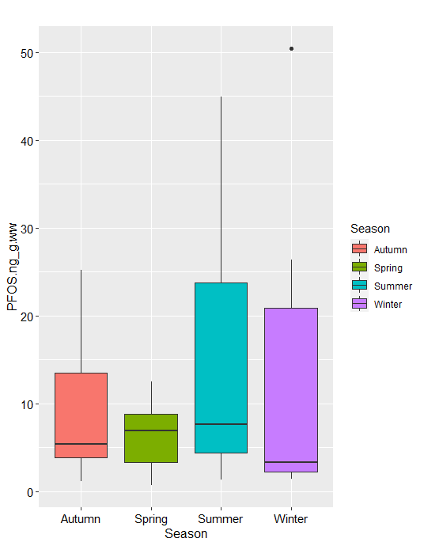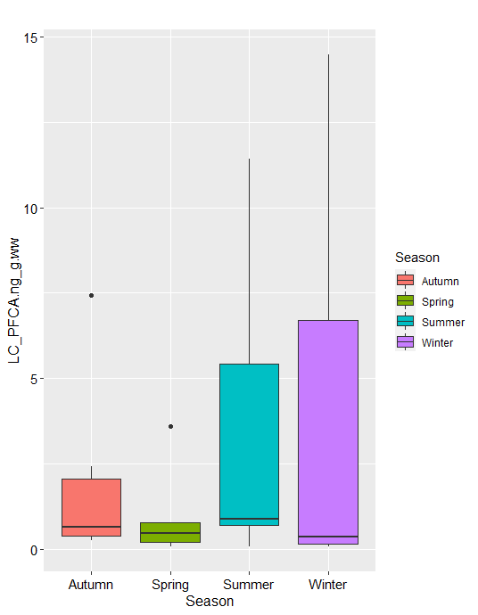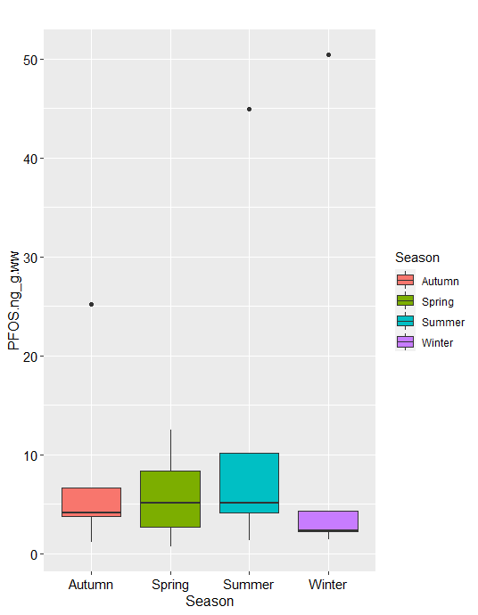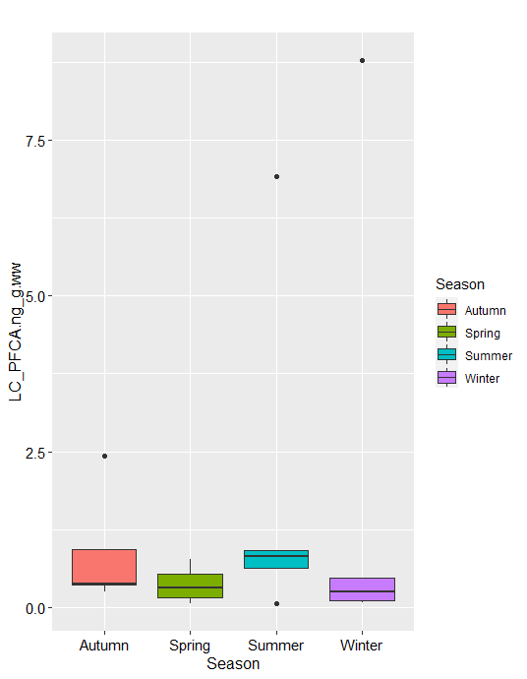

Figure S1 Box-whisker plot of the PFOS and long chain PFCA (C9-C12) fillet concentrations in different seasons (fish sampled in 2018 of Lake Como, Lake Garda, Lake Lugano and Lake Maggiore). Upper plots two species (shad and European perch); lower plot only shad samples. No statistical differences were observed (p>0.5).

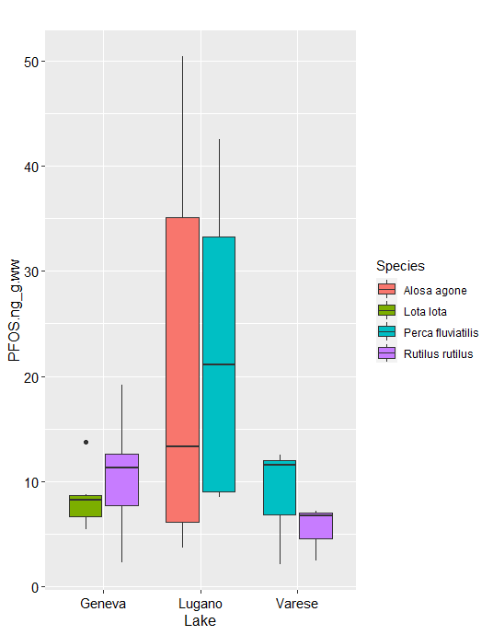 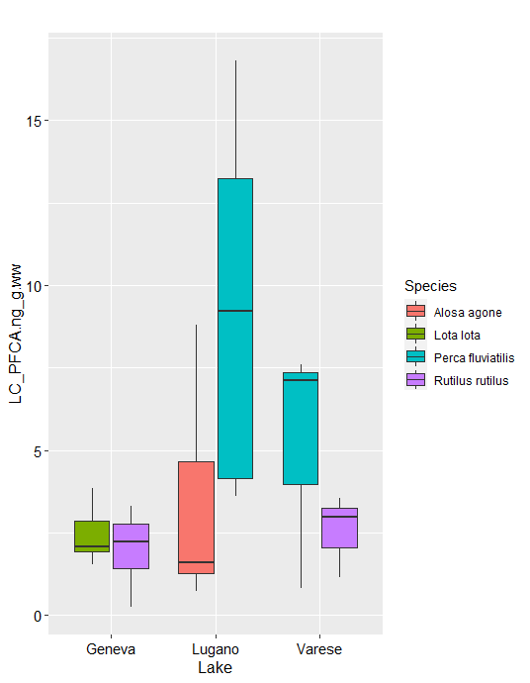

Figure S2 Box-whisker plot of the PFOS and long chain PFCA (C9-C12) fillet concentrations in different lakes by species. No statistical differences were observed (p>0.5).



Figure S3 Distribution percentage of PFAS in different fractions of different fish species



Figure S3 (*continued*) Distribution percentage of PFAS in different fractions of different fish species

Figure S4. Plots of concentration of PFAS in fillet of Lake Lugano (ng/gww) vs *a)* the dry weight fraction and *b)* the lipid fraction of the fish

***Iseo***

***Lugano***

***Geneva***

***Maggiore***

***Como***

***Garda***

***Lugano***

***Geneva***

***Maggiore***

***Como***

***Iseo***

***Garda***

Figure S5. Plots of medians of ∑Long Chain PFCA (above) and PFOS (below) concentrations vs Degurba Index (DUI)

Regression equations:

[∑LC- PFCA] = 0.043 (± 0.005) DUI - 0.5 (± 0.3) (R2=0.9413; p-value: 0.0013)

[PFOS] = 0.15 (± 0.04) DUI + 0.3 (± 2.0) (R2= 0.7983; p-value: 0.016)

REFERENCES

Ahrens L, Marusczak N, Rubarth J, Dommergue A, Nedjai R, Ferrari C, Ebinghaus R. 2010. Ahrens L, Marusczak N, Rubarth J, Dommergue A, Nedjai R, Ferrari C, Ebinghaus R. 2010. Distribution of perfluoroalkyl compounds and mercury in fish liver from high-mountain lakes in France originating from atmospheric deposition. *Environ Chem* 7:422-428. DOI: 10.1071/EN10025.

Ahrens L, Norstrom K, Viktor T, Cousins AP, Josefsson S. 2015. Stockholm Arlanda Airport as a source of per- and polyfluoroalkyl substances to water, sediment and fish. *Chemosphere* 129:33-38. DOI: 10.1016/j.chemosphere.2014.03.136.

Akerblom S, Negm N, Wu P, Bishop K, Ahrens L. 2017. Variation and accumulation patterns of poly- and perfluoroalkyl substances (PFAS) in European perch (Perca fluviatilis) across a gradient of pristine Swedish lakes. *Sci Total Environ* 599-600:1685-1692. DOI: 10.1016/j.scitotenv.2017.05.032.

Berger U, Glynn A, Holmstrom KE, Berglund M, Ankarberg EH, Tornkvist A. 2009. Fish consumption as a source of human exposure to perfluorinated alkyl substances in Sweden - analysis of edible fish from Lake Vattern and the Baltic Sea. *Chemosphere* 76:799-804. DOI: 10.1016/j.chemosphere.2009.04.044.

Bossi R, Dam M, Riget FF. 2015. Perfluorinated alkyl substances (PFAS) in terrestrial environments in Greenland and Faroe Islands. *Chemosphere* 129:164-169. DOI: 10.1016/j.chemosphere.2014.11.044.

Bradford MM. 1976. A rapid and sensitive method for the quantitation of microgram quantities of protein utilizing the principle of protein-dye binding. Analytical biochemistry. *Analytical biochemistry* 72:248-254.

Chiesa LM, Nobile M, Pasquale E, Balzaretti C, Cagnardi P, Tedesco D, Panseri S, Arioli F. 2018. Detection of perfluoroalkyl acids and sulphonates in Italian eel samples by HPLC-HRMS Orbitrap. *Chemosphere* 193:358-364. DOI: 10.1016/j.chemosphere.2017.10.082.

Filipovic M, Woldegiorgis A, Norstrom K, Bibi M, Lindberg M, Osteras AH. 2015. Historical usage of aqueous film forming foam: a case study of the widespread distribution of perfluoroalkyl acids from a military airport to groundwater, lakes, soils and fish. *Chemosphere* 129:39-45. DOI: 10.1016/j.chemosphere.2014.09.005.

Hansen S, Vestergren R, Herzke D, Melhus M, Evenset A, Hanssen L, Brustad M, Sandanger TM. 2016. Exposure to per- and polyfluoroalkyl substances through the consumption of fish from lakes affected by aqueous film-forming foam emissions - A combined epidemiological and exposure modeling approach. The SAMINOR 2 Clinical Study. *Environ Int* 94:272-282. DOI: 10.1016/j.envint.2016.05.030.

Holzer J, Goen T, Just P, Reupert R, Rauchfuss K, Kraft M, Muller J, Wilhelm M. 2011. Perfluorinated compounds in fish and blood of anglers at Lake Mohne, Sauerland area, Germany. *Environ Sci Technol* 45:8046-8052. DOI: 10.1021/es104391z.

Mazzoni M, Polesello S, Rusconi M, Valsecchi S. 2016. Liquid chromatography mass spectrometry determination of perfluoroalkyl acids in environmental solid extracts after phospholipid removal and on-line turbulent flow chromatography purification. *Journal of chromatography A* 1453:62-70. DOI: 10.1016/j.chroma.2016.05.047.

Palacios LE, Wang T. 2005. Egg-yolk lipid fractionation and lecithin characterization. *Journal of the American Oil Chemists' Society* 82:571-578.

Riviere G, Sirot V, Tard A, Jean J, Marchand P, Veyrand B, Le Bizec B, Leblanc JC. 2014. Food risk assessment for perfluoroalkyl acids and brominated flame retardants in the French population: results from the second French total diet study. *Sci Total Environ* 491-492:176-183. DOI: 10.1016/j.scitotenv.2014.01.104.

Rudel H, Muller J, Jurling H, Bartel-Steinbach M, Koschorreck J. 2011. Survey of patterns, levels, and trends of perfluorinated compounds in aquatic organisms and bird eggs from representative German ecosystems. *Environmental science and pollution research international* 18:1457-1470. DOI: 10.1007/s11356-011-0501-9.

Schuetze A, Heberer T, Effkemann S, Juergensen S. 2010. Occurrence and assessment of perfluorinated chemicals in wild fish from Northern Germany. *Chemosphere* 78:647-652. DOI: 10.1016/j.chemosphere.2009.12.015.

Squadrone S, Ciccotelli V, Favaro L, Scanzio T, Prearo M, Abete MC. 2014. Fish consumption as a source of human exposure to perfluorinated alkyl substances in Italy: Analysis of two edible fish from Lake Maggiore. *Chemosphere* 114:181-186. DOI: 10.1016/j.chemosphere.2014.04.085.

Squadrone S, Ciccotelli V, Prearo M, Favaro L, Scanzio T, Foglini C, Abete MC. 2015. Perfluorooctane sulfonate (PFOS) and perfluorooctanoic acid (PFOA): emerging contaminants of increasing concern in fish from Lake Varese, Italy. *Environmental monitoring and assessment* 187:438. DOI: 10.1007/s10661-015-4686-0.

Zafeiraki E, Gebbink WA, Hoogenboom R, Kotterman M, Kwadijk C, Dassenakis E, van Leeuwen SPJ. 2019. Occurrence of perfluoroalkyl substances (PFASs) in a large number of wild and farmed aquatic animals collected in the Netherlands. *Chemosphere* 232:415-423. DOI: 10.1016/j.chemosphere.2019.05.200.